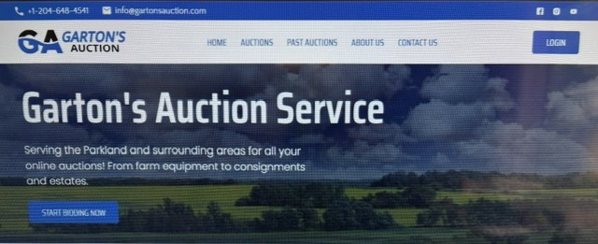

Business for Sale – Garton's Auction Service

Exceptional Opportunity to Own an Established Online Auction Business
After years of building one of Manitoba's recognized online auction companies, Garton's Auction Service is now being offered for sale.
This is a turnkey opportunity for an entrepreneur, auctioneer, or existing auction company looking to expand. The business has an established reputation for conducting online farm, estate, equipment, and consignment auctions throughout the Parkland region and surrounding areas.

Business Highlights
- Established and respected brand with a loyal customer base.
- Fully operational online auction platform and website.
- Active database of buyers and sellers.
- Strong social media presence and marketing channels.
- Proven relationships with estate representatives, farmers, businesses, and consignors.
- Opportunity for continued growth throughout Manitoba and beyond.
- Training and transition assistance available to the purchaser.
This is an ideal opportunity for someone seeking an established business with an excellent reputation and significant growth potential.
Serious inquiries only. A Non-Disclosure Agreement (NDA) with a $250.00 Refundable deposit will be required before confidential financial and operational information is released.
For additional information or to discuss this opportunity, please contact:
Larry Garton
Garton's Auction Service
Phone: (204) 648-4541

